**Pentaho Data Integration**

**Assignment-3**

1. Copy an airline table data from the source to the target database using PDI Wizard.

To add the CSV file input and dummy

To connect the path CSV to dummy

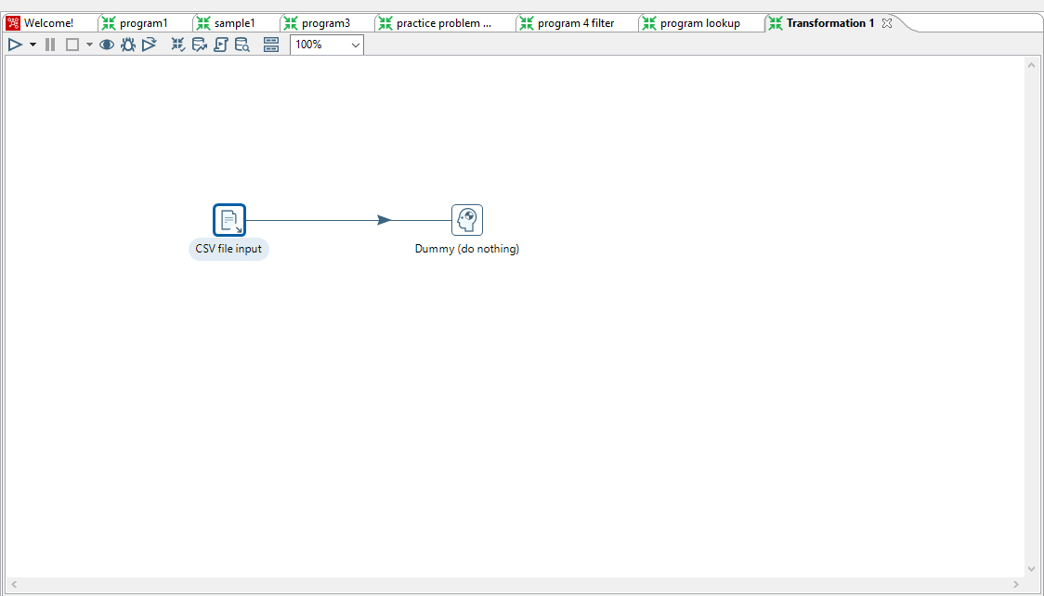

To add the Airline CSV input file and getting the get fields then click ok.

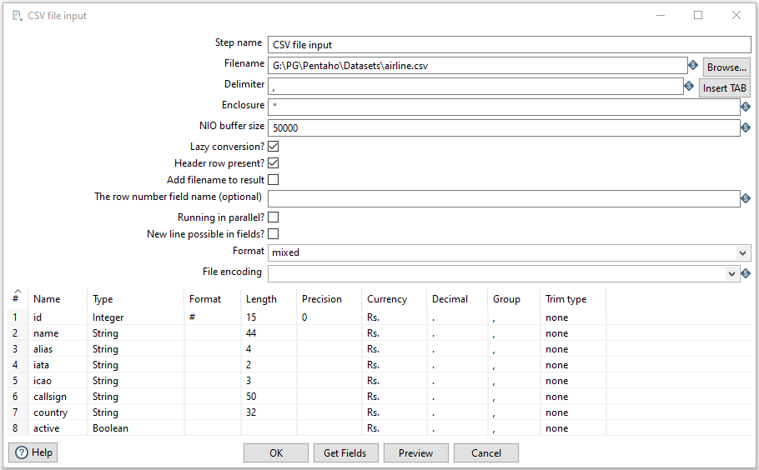

Output

Finally to read the Airline dataset in PDI Wizard.

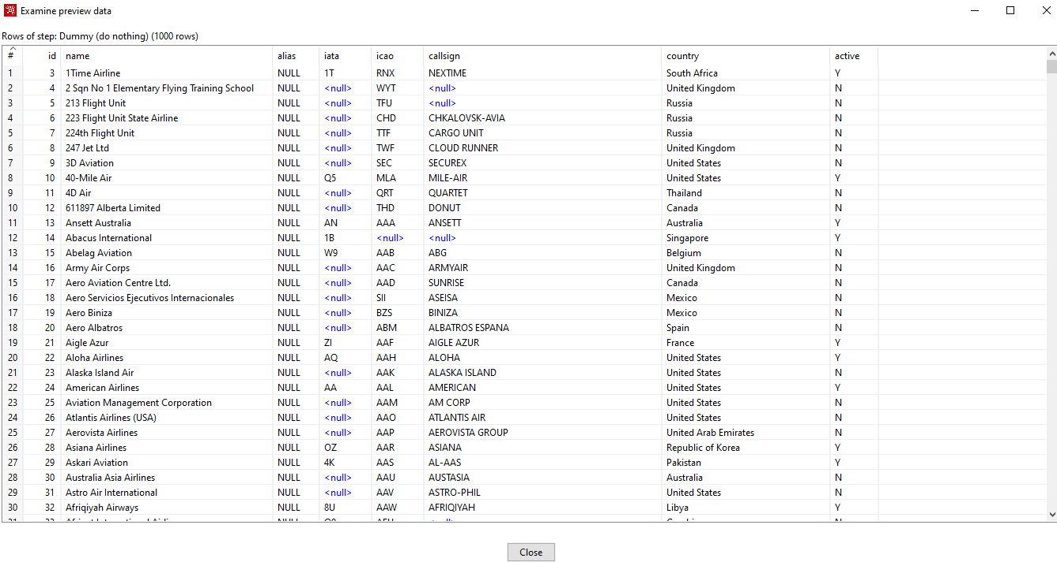

1. Open an example from Samples named Sample superstore- Basic example and see its preview.

To add the CSV file input, filter rows and two dummy

Set the path properly for shown figure and set True or False condition

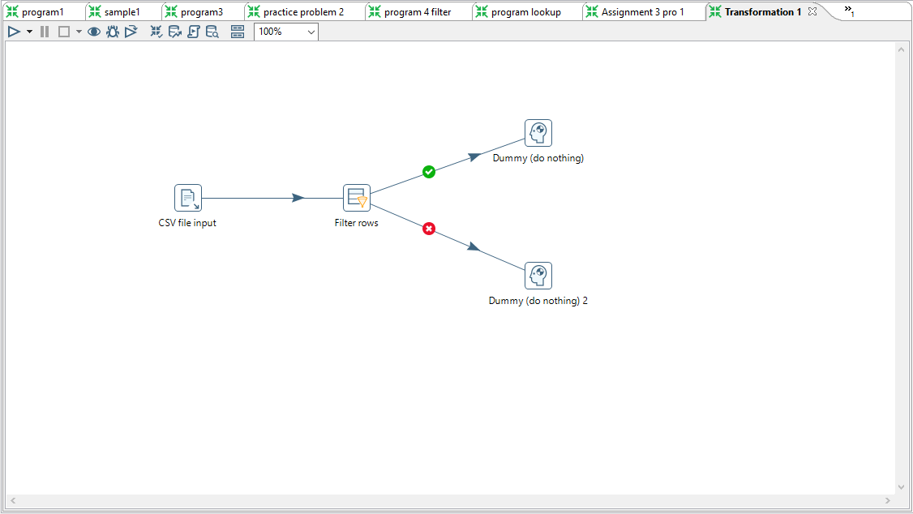

To add the sample superstore csv file and getting the fields then click ok.

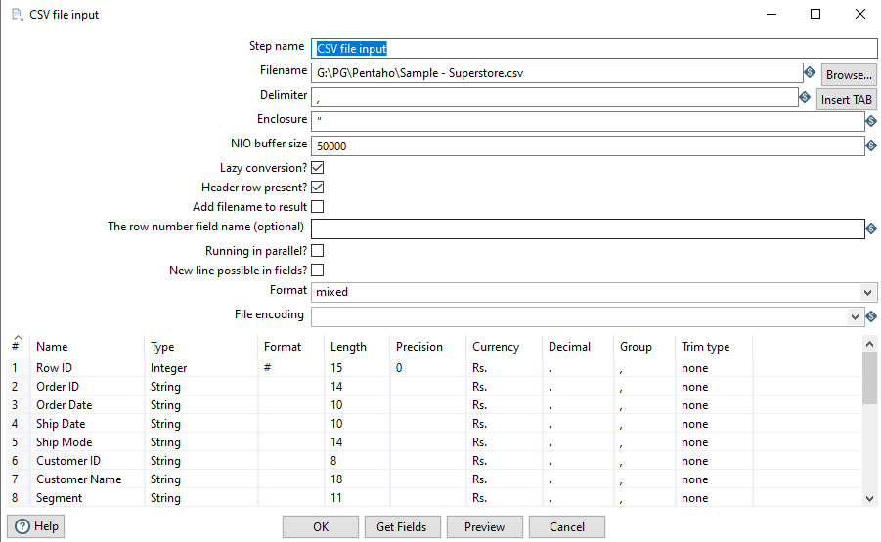

Getting a specified records using filter rows and the condition feature is Ship mode and value is equal to Second Class

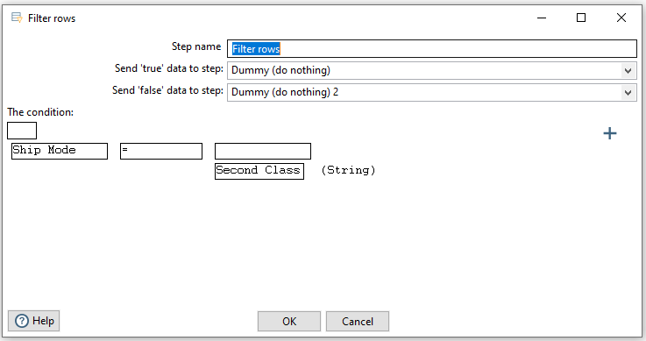

Output

Dummy 1 ship mode filtered vales it have only second Class values.

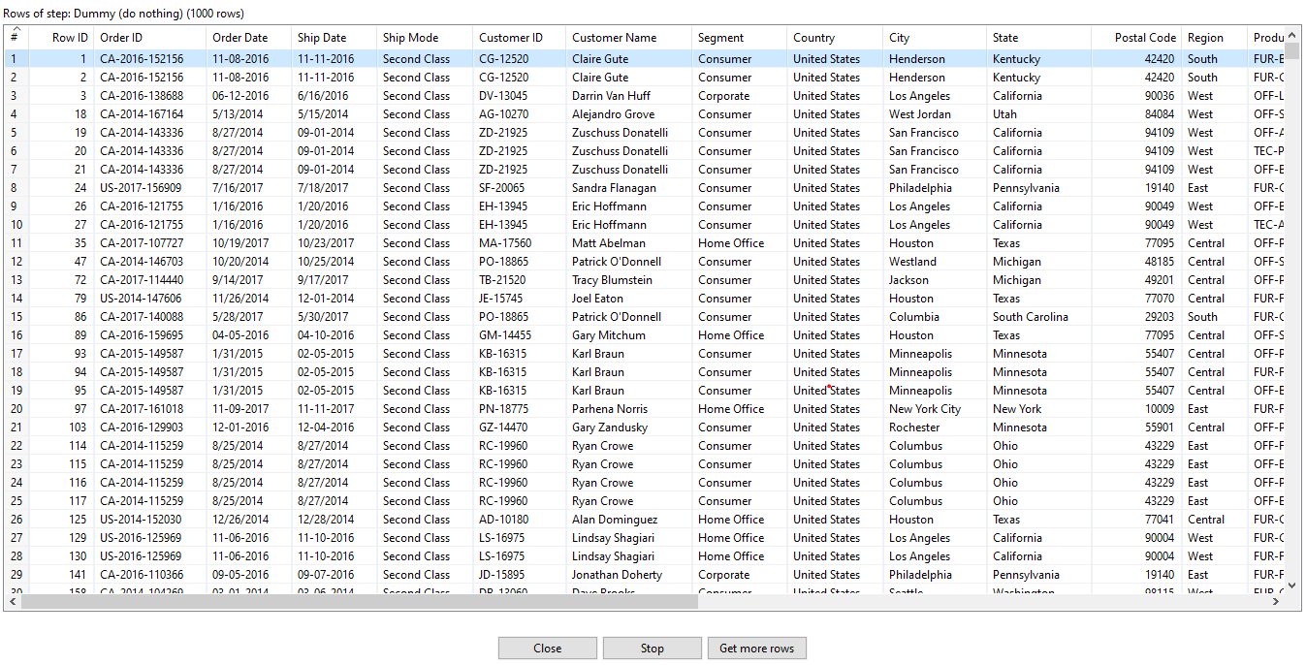

Dummy 2 It’s not filtered so taking a all values from ship mode feature.

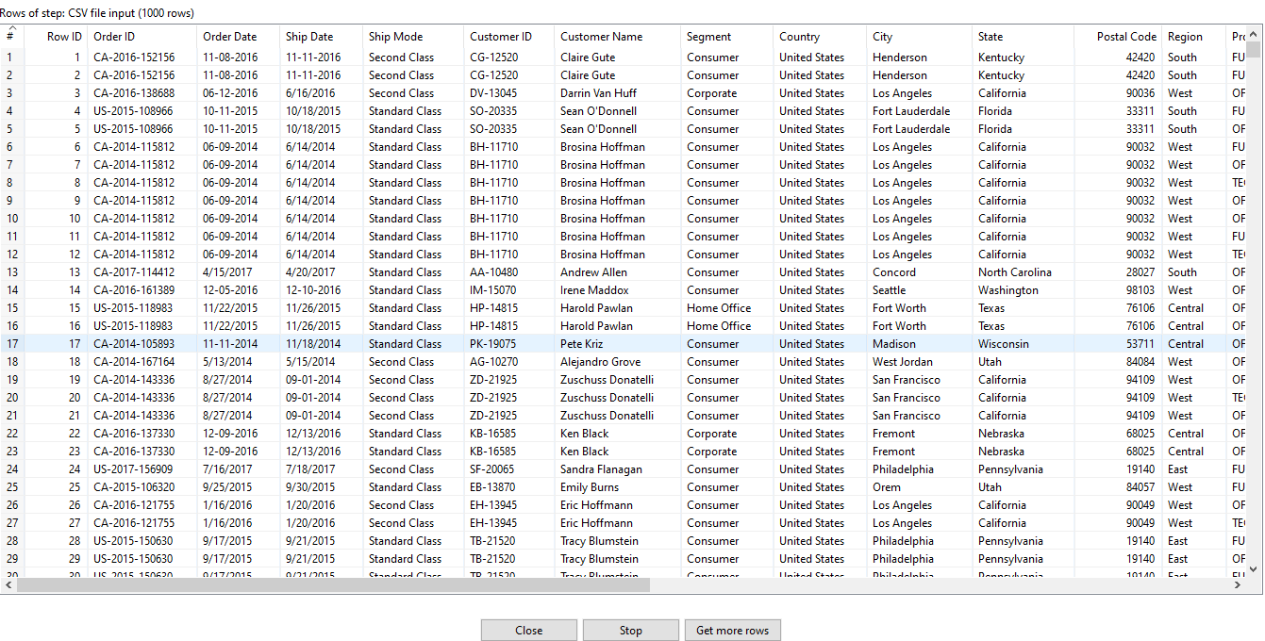

1. Open an example from Samples named Sales Data - Basic example and see a preview.

To add the CSV file input, filter rows and two dummy

Set the path properly for shown figure and set True or False condition

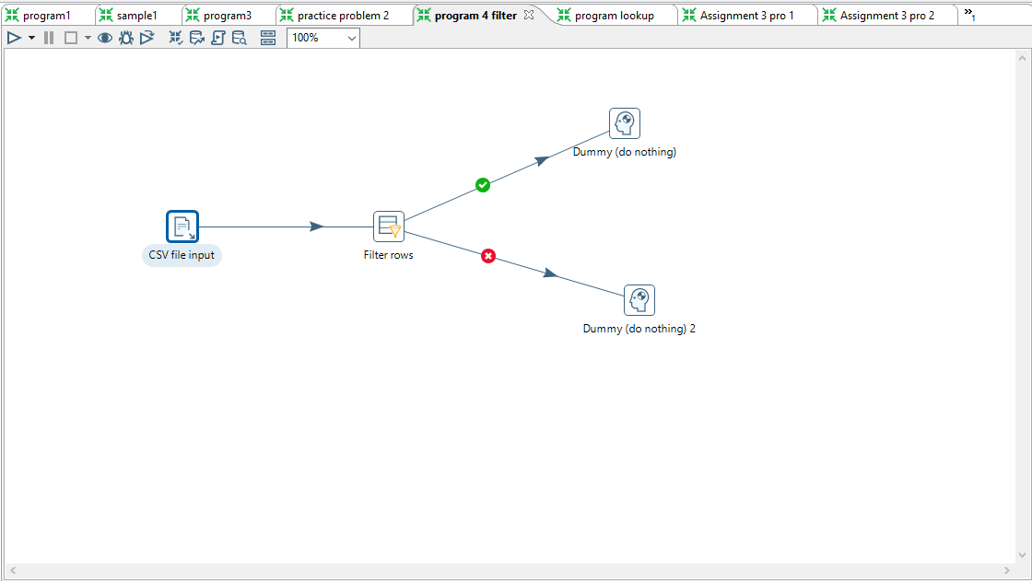

To add the Salesdata csv file and getting the fields then click ok.

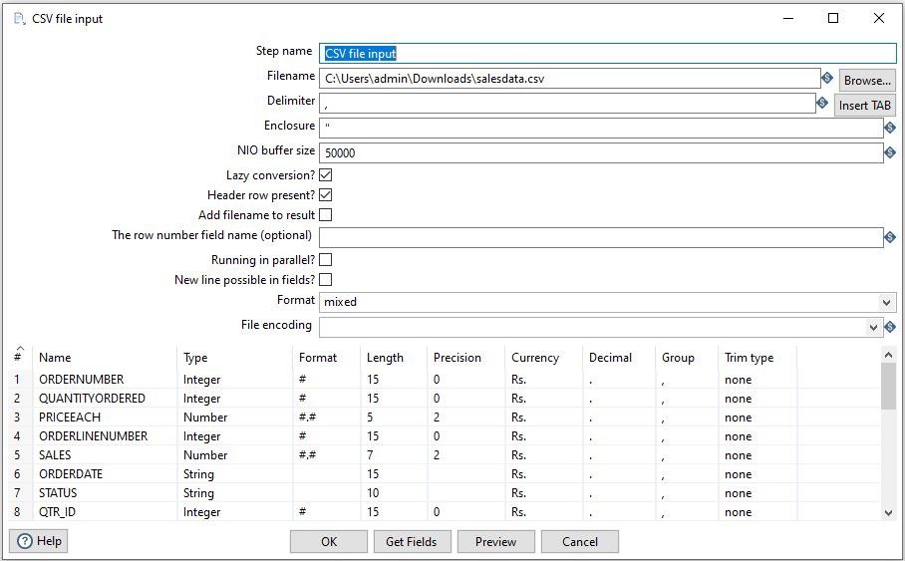

Getting a specified records using filter rows and the condition feature is country and value is equal to USA

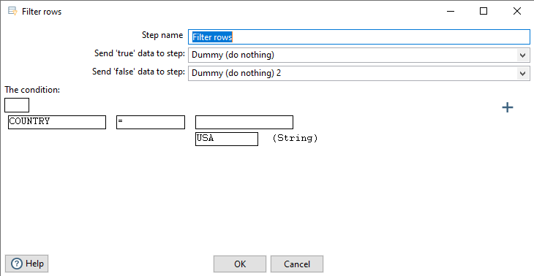

Output

Dummy 1 country filtered vales it have only USA values.

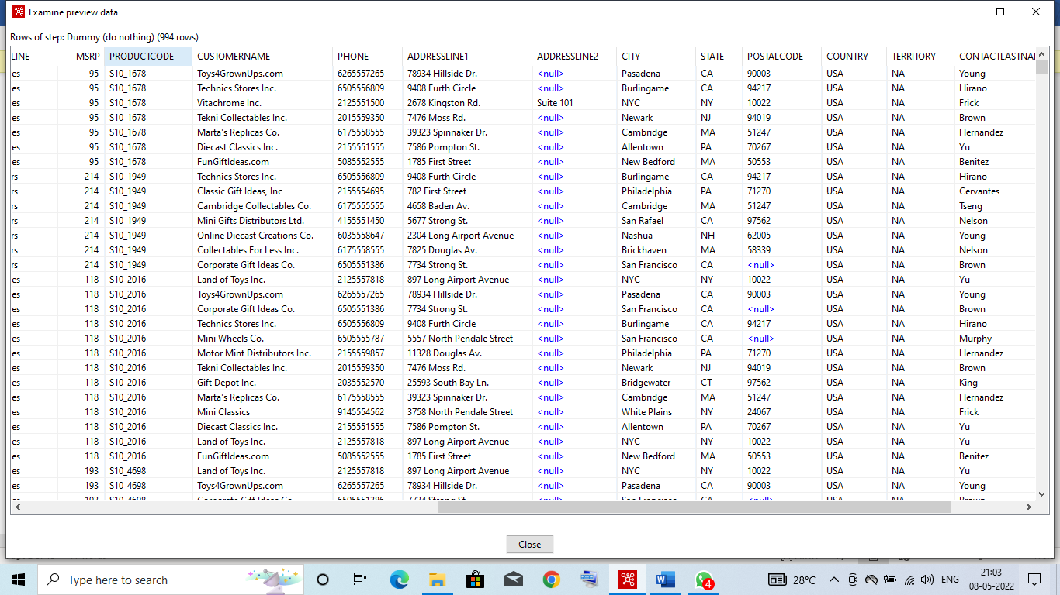

Dummy 2 It’s not filtered so taking a all values from country feature.

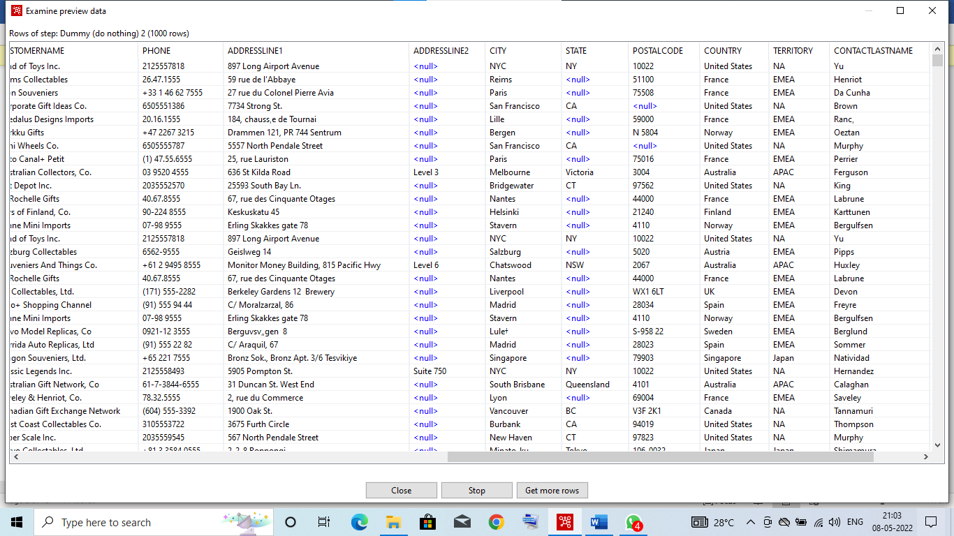

1. Load sales data by resolving missing ZIP codes from lookup and load it to the table.

To add the Two CSV file input, filter rows, Stream lookup and Excel output.

Set the path properly for shown figure and set only True condition for filter rows.

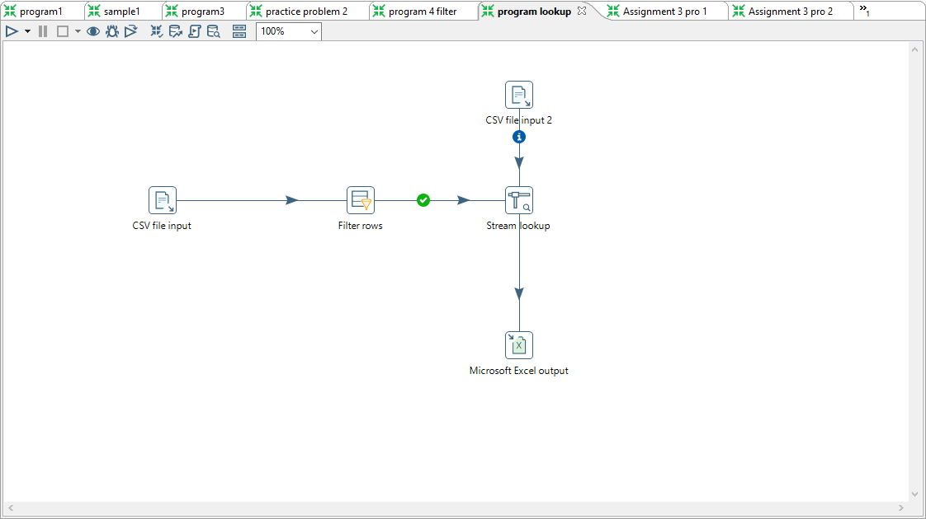

To add the Salesdata csv file for two input csv and getting the fields then click ok.

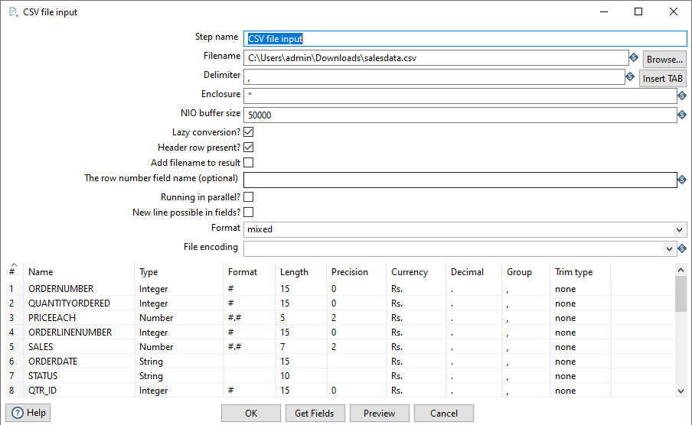

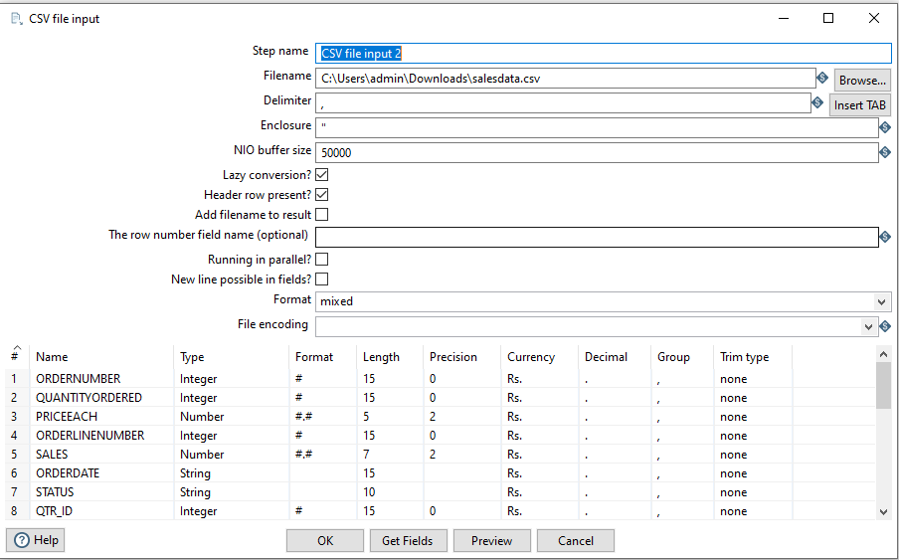

Getting a specified records using filter rows and the condition feature is country and value is equal to USA

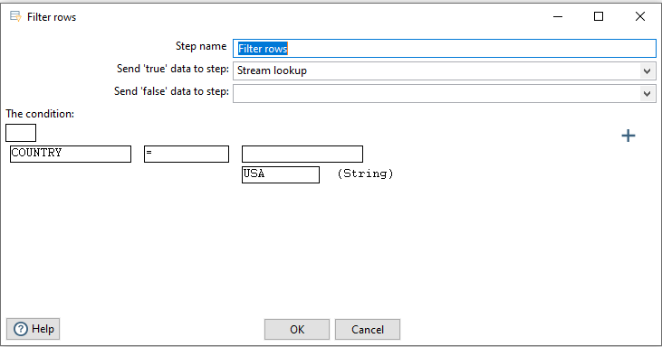

To set the Exact match for country in two input csv files

To retrive the selected fields only

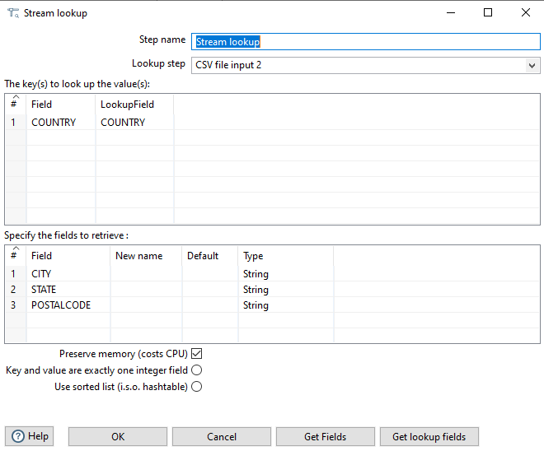

Output

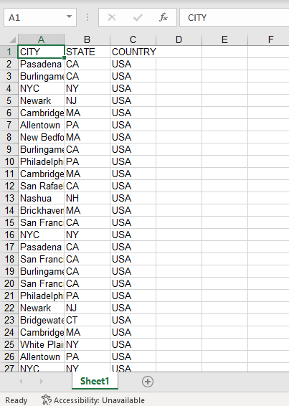

1. Build a transformation that will look like below.

